Summative Assessment for the cross curricular unit «Art and Music»
Name:_______________________________ Date:_________________
Reading
1. Read the text and answer the questions. Complete sentences.
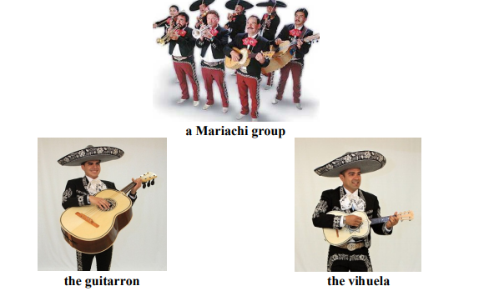
Mexican Mariachi Music
Mariachi music is a popular type of Mexican music. Mariachi groups need seven people to play the instruments. Two people play the violin, two people play the trumpet, one person plays the Spanish guitar, one person plays the guitarron and one person plays the vihuela.
The people playing the instruments in the Mariachi group also sing. They sing about love and feeling happy.
1. How many people need to be in a Mariachi group?
A Mariachi group needs ________________________________________________ people.
2. What instruments has Mariachi music got? (write the names of 3 instruments)
Mariachi music has got _________________________________________________________.
3. What topics do the Mariachi singers sing about?
They sing about _______________________________________________________________. Total: ___/5

Speaking
Task 2. Listen to the teacher’s questions and answer them in full sentences.
1. Do you like Kazakh music?
2. What is your favourite musical instrument?
3. What is your favourite song?
4. Do you listen to Kazakh music? Why do/don’t you listen to Kazakh music?
5. Imagine you went to a music museum with your class yesterday. What did you see there?
Toal:__/5
Total:__/10

