3 GRADE. SUMMATIVE ASSESSMENT WORK FOR THE 3 TERM
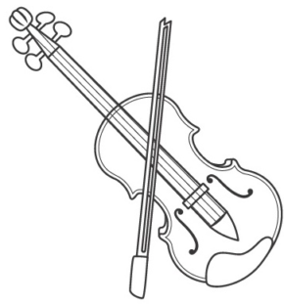
Listening
Task 1. Listen and choose True or False. Послушай и выбери “True/False”.
- Violin is a string instrument. _____________
- It is the biggest instrument in the string family. _____________
- If you play the violin, you are the pianist. _____________
- The violin is a very old instrument. _____________

Reading
Task 2. Read the text. Answer the questions. Choose only ONE answer. Circle the answer.
Прочитай текст. Ответь на вопросы. Выбери только ОДИН ответ. Обведи его.
My last Birthday
I’m John. My birthday is on 5th August. On my last birthday I had a big party. My friends arrived at 6 o’clock. They gave me lots of presents and cards. We ate pizza and burgers and drank orange juice. Then, I blew out 8 candles on my cake and they all sang “Happy Birthday” to me! It was a great birthday!
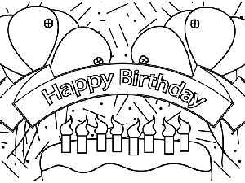
Circle the correct answer. Обведи правильный ответ.
1. When is John birthday?
A. 7 August B. 5 August C. 5 September
2. What did they eat?
A. pizza and burgers B. cake C. fruits
3. How many candles did John blow?
A. 7 candles B. 9 candles C. 8 candles
4. When did his friends arrive?
A. 5 o’clock B. 6 o’clock C. 16 o’clock

Writing
Task 3. Write the sentences correctly. Запиши предложения правильно
- I ______________ (go) to the cinema yesterday.
- She _________________ (not/bring) her pencil case to school.
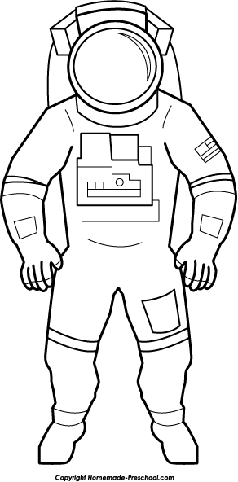
- We all __________________ (dance) at Dana’s party.
4. ________they_____________ (swim) yesterday?

Speaking. Task 4. Read the questions aloud. Answer them in complete sentences.
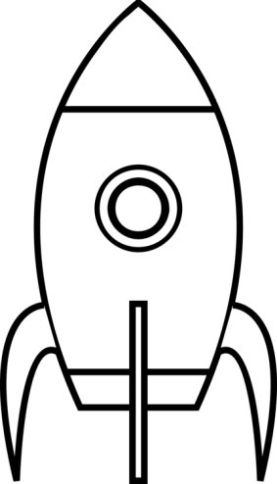
Прочитай вопросы. Ответь на них полными ответами.

- What is the name of the cosmodrome in Kazakhstan? ____
- What region is the cosmodrome in? ____
- What month comes before July? ____
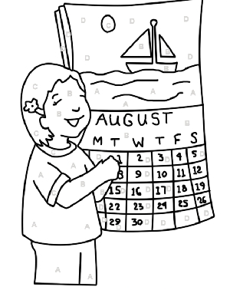
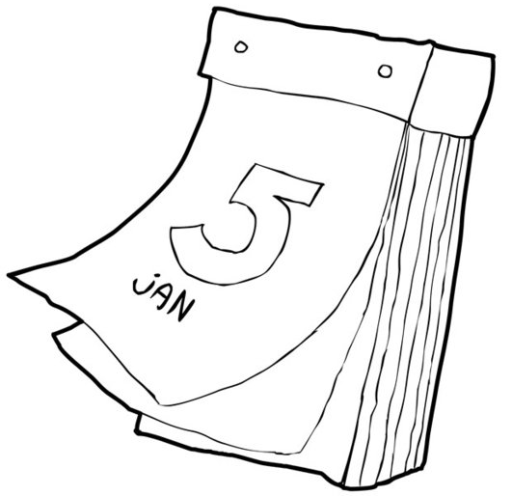
- What month comes after August? ____

Task | Descriptor | Mark
1 | Writes “True” | 1
1 | Writes “False” | 1
1 | Writes “False” | 1
1 | Writes “True” | 1
2 | Chooses “B” | 1
2 | Chooses “A” | 1
2 | Chooses “C” | 1
2 | Chooses “B” | 1
3 | Writes “I went…..” | 1
3 | Writes “didn’t bring” | 1
3 | Writes “danced” | 1
3 | Writes “Did they swim” | 1
4 | Says “Baikonur Cosmodrome” | 1
4 | Says “Kyzylorda region/oblast” | 1
4 | Says “June” | 1
4 | Says “September” | 1
Total marks |  | 16

