Sample questions and mark scheme
Tasks for the Summative Assessment for the term 1
LISTENING
Task
Part 1. Listen to the recording twice and underline an odd word.CD3.Tapescript 1.
1. [a:] park market bag [1]
2. [i] circus cinema disco [1]
3. [u:] zoo pool post [1]
Part 2. Listen to the recording twice and number the pictures. The first picture is done for you as an
example.
F_1__
4.A [1]  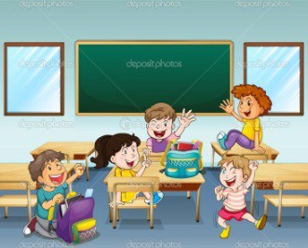 | 5.B [1]   | 6.C [1]  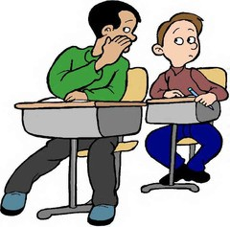

READING
Task. Read the text about four learners’ daily routine.
What do they do after school?
My name is Max. After school, I help my mum and dad. Then I go to the park. There I meet my friends and we play different games. When I come home I usually play chess.
I am Julia. After school, I like drawing and painting pictures. Then I write stories. I put the stories and pictures on my bedroom wall.
I am Luke. After school, I do my homework. Then I listen to my CDs and when I have some spare time I sing songs. In the evenings I prefer reading.
My name is Sara. I go swimming every Monday. I play tennis with my friends every Tuesday. Every Thursday I skate in the park with my sister.
Read the text again and identify who does each activity. Write the learners’ names or first
letters next to the phrases. The first task is done for you as an example.
M = Max, J = Julia, L = Luke, S = Sara.
Example: go to the park M___
1. enjo y A r t ____ [1]
2. do sport activities ____ [1]
3. like music_________[1]
4. keen on reading____ [1]
5. spend time with friends ____ [1]
6. do hous e w o r k ____ [1]
Total_____ [6]
WRITING
Task. Your pen- friend has sent you a postcard of his/her room.
Write a postcard to your friend about your room. The sample postcard will help you to write a reply.
Hello dear friend,
This is my room. My room is not very big, but it is a nice. There is a big sofa in my room. Can you send me a postcard of your town? How big is your room? What is there in your room? Do you like your room?
Love,
Alex
Write your answer to Alex. Make a plan of your writing and answer the questions.
___________________________________________________________________________
___________________________________________________________________________
___________________________________________________________________________
___________________________________________________________________________
__________________________________________________________________________________

Total ________[6]

SPEAKING
Task. Choose one of the pictures below and describe it. Answer the questions:
• What can you see in the picture?
• Where are people or cartoon characters?
• What have they got?
• Do you like the picture?
Total ________[6]
Total marks _____/24

Mark scheme Listening and Reading

№ | Answer | Mark | Additional information
1.  2.  3.  4.  5.  6. | Bag | 1
1.  2.  3.  4.  5.  6. | Circus | 1
1.  2.  3.  4.  5.  6. | Post | 1
1.  2.  3.  4.  5.  6. | A3 | 1
1.  2.  3.  4.  5.  6. | B2 | 1
1.  2.  3.  4.  5.  6. | C1 | 1
1.  2.  3.  4.  5.  6. | J | 1
1.  2.  3.  4.  5.  6. | S | 1
1.  2.  3.  4.  5.  6. | L | 1
1.  2.  3.  4.  5.  6. | L | 1
1.  2.  3.  4.  5.  6. | M | 1
1.  2.  3.  4.  5.  6. | M | 1
Total |  | 12

