Summative Assessment for the unit “The natural environment”
Total mark______________(14)
Name _________________ Class _____________________
Task 1.
Listening
Task 1. Look at the pictures. Listen and circle
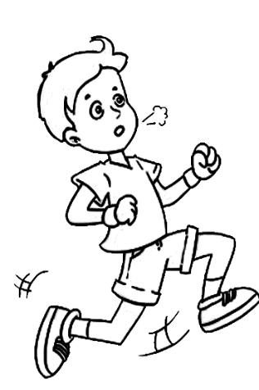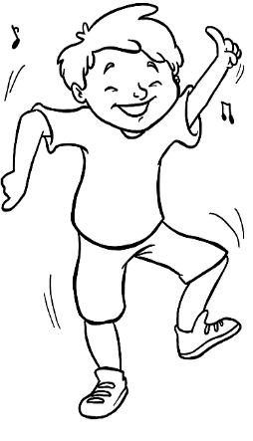
1
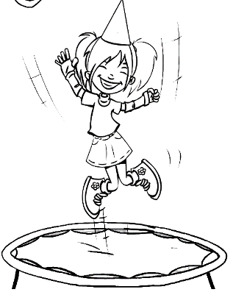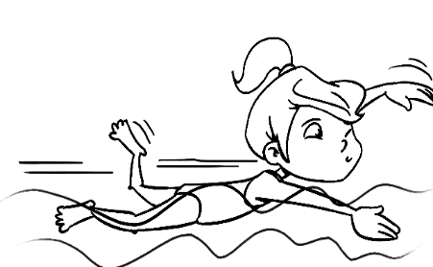
2

A
A

B
B

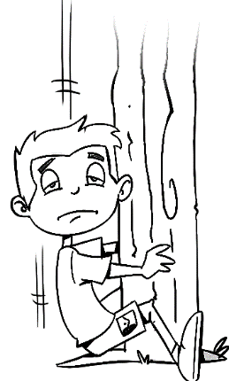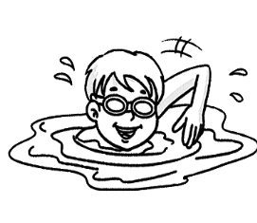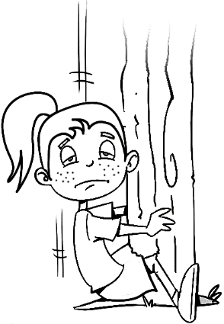
3
4

A

A
B
B

Marks (4) _____________
Task 2
Read and write “Yes” or “No”.
5 |  | Dogs can jump | ___________
6 |  | Horses can sing | ____________
7 |  | Chimps can fly. | ___________
8 |  | Snakes can crawl | ___________
9 |  | Frogs can dance. | ___________
10 |  | Rabbits can hop | ___________

Marks (6) ______________

Task 3 Look, read and match
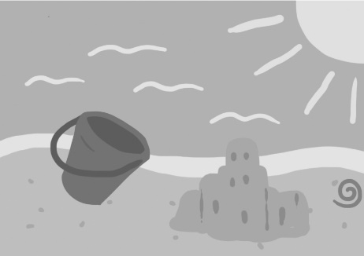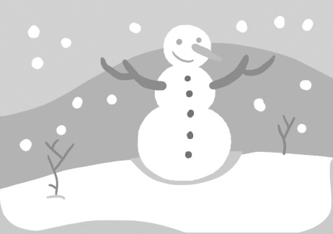
11
12
13
14
SUMMER

AUTUMN

WINTER

SPRING

Marks (4) ______________

SA_Unit 6_The natural environment Total mark______________(14)
Name _________________ Class _____________________
Task 1.
Listening
Task 1. Look at the pictures. Listen and circle
1
2

A
A

B
B

3
4

A

A
B
B

Marks (4) _____________
Task 2
Read and write “Yes” or “No”.
5 |  | Dogs can jump | ___________
6 |  | Horses can sing | ____________
7 |  | Chimps can fly. | ___________
8 |  | Snakes can crawl | ___________
9 |  | Frogs can dance. | ___________
10 |  | Rabbits can hop | ___________

Marks (6) ______________

Task 3 Look, read and match
11
12
13
14
SUMMER

AUTUMN

WINTER

SPRING

Marks (4) ______________

