Summative Assessment for the Cross curricular unit “Food and drink”
Name:_____________________________________ Date:_________
1. Reading
Read short sentences and match them to the pictures
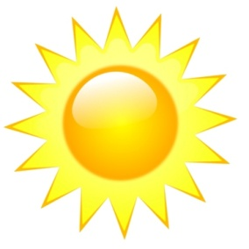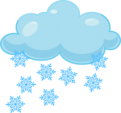

It`s cloudy It`s sunny It`s snowy It`s rainy
Total: _/3
2. Speaking
Listen to the questions and answer them. Use the pictures to help you
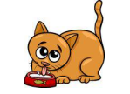 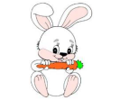 Total:__/4
3. Use of English
Make sentences in Present Simple. Use the words from the box
like likes Do you like

1. He ________ pizza.
2. I _______ orange juice.
3. ___________ milk?
Total:__/3

Total: __/10

