SA_Unit 7 _”Food anddrink” Total mark______________(11)
Name _________________ Class _____________________

- Listening
Listen to the teacher’s story about Jack and draw this smile , if he likes, and this smile, if he doesn’t like.
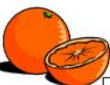 | 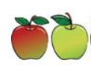 |  | 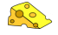 | 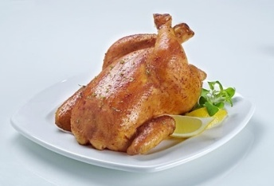

Mark _______ (5)

- Reading
Look at the following pictures. Read and circle the right words.
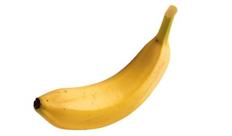 |  |  | 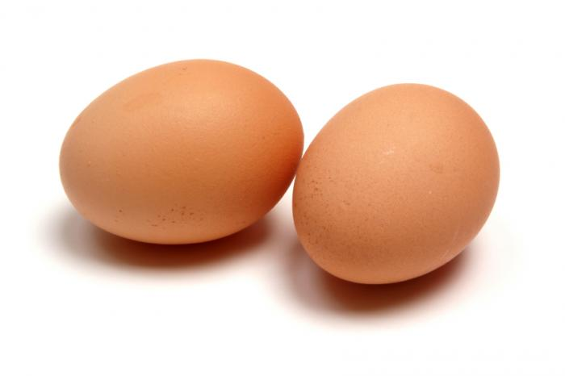 |  |  | 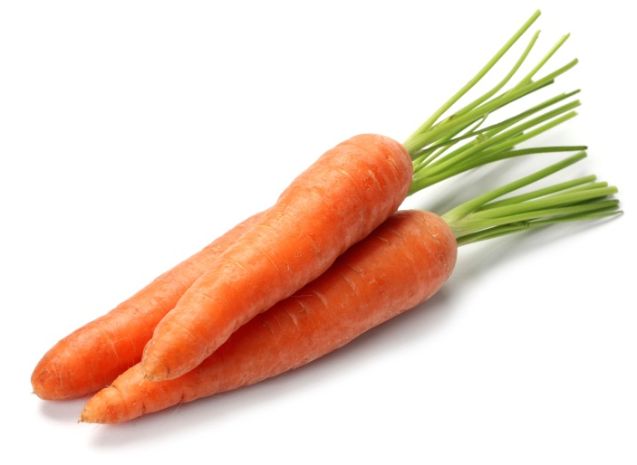
sun | desk | banana | eggs | milk | pen | apple | carrots | fox

Mark _______ (3)
- Writing
Write the fist letters of these words (Напиши первые буквы этих слов)
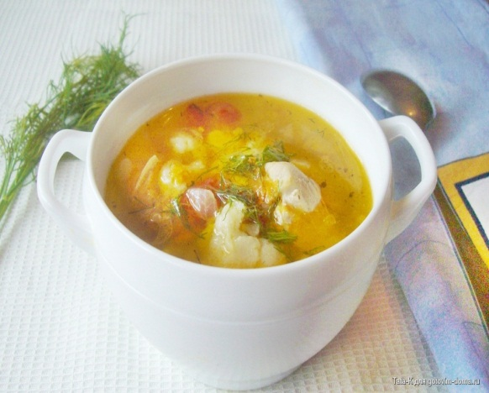 | ______________________
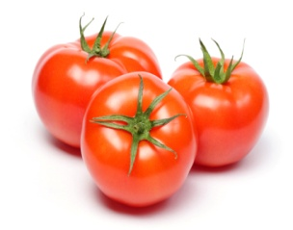 | ______________________
 | _________________________

Mark _______ (3)
SA_Unit 7 _”Food anddrink” Total mark______________(11)
Name _________________ Class _____________________

- Listening
Listen to the teacher’s story about Jack and draw this smile , if he likes, and this smile, if he doesn’t like.

Mark _______ (5)

- Reading
Look at the following pictures. Read and circle the right words.
sun | desk | banana | eggs | milk | pen | apple | carrots | fox

Mark _______ (3)
Writing
Write the fist letters of these words (Напиши первые буквы этих слов)
______________________
______________________
_________________________

Mark _______ (3)

