Summative assessment for the unit “Creativity”
Name__________________________________________________________________class 5 ”___” I- variant

1. Label the names of mythical creatures

__________________ __________________ ____________________ _____________________

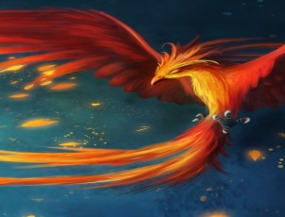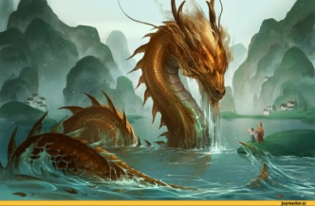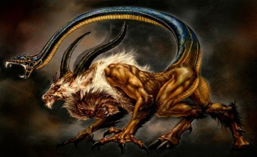

__________________ _____________________

Dragon, Cyclops, Centaurs, Chimera, Phoenix, Unicorn
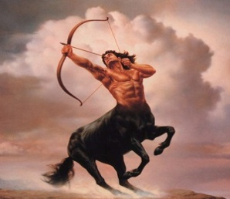 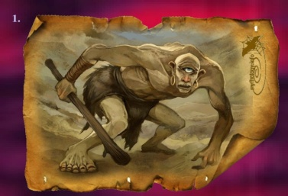 ___/6

2. Complete the sentences with: WAS or WERE
a) Serik _____ at school yesterday.
b) They ______ at the gym last Sunday.
c) She ______ at home yesterday morning
d) Peter and Helen _____ at the cinema yesterday.
e) _____ you at the cinema yesterday evening?
f) ____ Peter at home yesterday? ____/6

3. SPEAKING. Use the verbs below and make 3 sentences what could and couldn`t you do at the age of seven:

Speak English, read, swim, ride a bicycle, draw, cook, play football, dance

For example: I could read but I couldn`t speak English at the age of seven. ____/3

Total: __|15_

